Foreword

RT-Thread was born in 2006, and now more ten years has passed. Several years ago I knew Mr. Fire on the internet, remembering clearly at that moment Fire was not so popular as now(he just started making development boards) and RT-Thread was also a niche RTOS(Real Time Operation System).I haven’t met Fire until the middle of 2018 when Fire came to the city of Shanghai, we said “**You are so young that looks unlike a strength pie.**” to each other.

In the end of 2017 when I heard Fire was planning to write a book about RT-Thread, I was quite exciting and full of appreciation. It would be the first book about RT-Thread and would play an important role in the spread of RT-Thread’s basic ecological chain. Moreover, as a RT-Thread’s official partner, Fire has planted a host of demos to all of his STM32 developing boards and a hand by hand course was provided to each demo.

There are two parts of this book written by Fire. The first part tells you how to construct RT-Thread from 0 to 1, from assemble language step by step to a RT-Thread kernel. This part unveiled how to define tasks, how to switch between tasks, and also described how to implement a delay in task, how to support multi priority, how to implement software timers and how to implement round-robin scheduling and the like. All of these are the basic and core knowledge of RT-Thread OS. The second part showed how to develop applications based on RT-Thread, and this will make readers do not have difficulty when learning and using RT-Thread.

The content of this book goes from shallow to deep, from easy to difficult step by step. It is exactly same as the beginners’ path, and there’s no better book than this one to learn RT-Thread. In addition, the whole book also takes into account the depth of the operating system, and are also worth to reading for readers who want to know the theory of RTOS kernel.

Father of RT-Thread 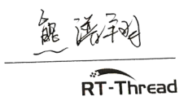

Both the electronic version of this book and demo codes can be downloaded at the following Wechat official accounts.

Fire electronic RT-Thread Home of Chips



Ch1 Preface

1.1 About This Book

This book is the RT-Thread version of the wildfire embedded teaching series "RTOS Kernel Implementation and Application Development Practice Guide". *The FreeRTOS* Kernel *Implementation and Application Development Practice Guide Based on STM32* published by the mechanical industry press is the companion volume of this book. Both books are written for RTOS, but they are aimed at different RTOS objects, so there will be many similarities in the theoretical part of the book that involves the abstract layer of RTOS. The specific differences are reflected in the implementation principle and code level of these two RTOS.

This book is divided into two parts. The first part is "*Teach you to write RT-Thread kernel from 0 to 1*". The chapter name of this part is basically similar to the chapter name of its companion volume "*FreeRTOS Kernel Implementation and application development practice guide - based on STM32*". It arranges the chapter number and name in a step-by-step and layer by layer manner, but the specific content is different because they are two different RTOS. The two chapters "*New RT-Thread Project Software Simulation*" and "*Bare Machine System and Multitask System*" belong to the abstract layer of theory, they are not specific to any RTOS, so they are basically the same.

The second part of this book is "RT-Thread Kernel Application Development", which mainly explains the source code implementation of RT-Thread kernel components and the use of API. It is also similar to its companion volume "*FreeRTOS Kernel Implementation and application development practice guide based on STM32*" in chapter naming and sorting. The theoretical explanation of the common abstract layer of RTOS, such as what is task, blocking delay and semaphore application are basically similar, but when it comes to the principle implementation and code explanation of these two RTOS, it is totally different, and the knowledge of this part is the content that readers should really care about.

I classified these two books as companion volume because the writing style, content framework, chapter naming and sorting of the two books are basically the same, the language description is similar, and the theoretical part related to the RTOS abstraction layer is the same, but the implementation principle, kernel source code explanation and user APIs use of RTOS are different. These contents are the book's key part and the core of readers' concern and learning. The two books can't be combined into one due to these differences, so they are divided into two books.

If you have studied one of the books, and now study another one. The theoretical part related to the RTOS abstraction layer can be skipped, just focus on the implementation of RTOS kernel and the application of source APIs. The existing RTOSs are basically same at the theoretical level, but have their own characteristics in the specific code implementation, so the two books can be used as complementary learning. As long as you mastered the knowledge of one book and then learn the other one, it will be a piece of cake for you and seems God is helping you.

1.2 How to Learn This Book

This book is the first English book on RT-Thread system, which is divided into two parts. The first part "from 0 to 1, teach you to write RT-Thread kernel", that is, focus on the principle of RT-Thread’s implementation, start from 0, iterate continuously, teach you how to write RT-Thread kernel, let you thoroughly learn how to define thread, how to schedule the system (including the assemble language codes’ explanation), how to implement multi priority and so on. All of these are the deepest knowledge of operation system. When you get this book and start to learn, you will be surprised that learning RTOS is not so complicated, but rather so interesting. It turns out that you can write RTOS as well, and your sense of achievement will immediately bursts.

When you have mastered the knowledge of the first part thoroughly, it is easy to learn other RTOS. Looking at several popular RTOSs on the market, the implementation of their kernel is basically similar, only one of them needs to be studied in depth and it is unnecessary to learn all of them deeply. If you have time, it doesn't matter. The second part is "*RT-Thread Kernel Application Development*", focusing on RT-Thread porting, application of each component of the kernel, which is easier to master than the first part.

The content of the whole book is gradual and iterative. The former chapter is the basis of the latter chapter, which must be read from the beginning instead of jumping. When learning, the two things are must to be done: first, we should combine code with books to learn rather than read books blindly, Reading and debugging at the same time. Reading is very simple, but how to debug the code? That is, to execute every program step by step, to see whether the execution process and effect of the program are the same as what you designed in your brain; secondly, after finished each chapter, you must rewrite the demo codes (typing letter by letter, you can copy but should not paste even a semicolon), to make sure you have really understood. When you write by yourself, you will surely make a hundred mistakes. At this time, you should cherish these mistakes and debug them until they are addressed. This is the best opportunity for you to improve your programming ability. Remember that the program is not written in one time, but debug step by step.

1.3 Reference

1.RT-Thread official source code

2.*RT-Thread_manual.zh*.pdf (electronic version)

3. *STM32 KuKaiFaShiZhanZhiNan* (electronic version)

1.4 Writing Style of This Book

The first part of this book is based on the official source code of RT-Thread nano 3.0.3. It is a continuous iteration to teach you how to write the RT-Thread kernel from 0. The data types, variable names, function names, file names, and file storage locations involved in the book are all implemented in the official way of RT-Thread. After you finished the book, you can seamlessly switch to make use of the raw RT-Thread. It should be noted that in the process of implementation, some parameters of functions and redundant codes are removed, and only the core functions are retained, but this will not affect learning.

The second part of this book mainly talks about the porting of RT-Thread and the using of kernel components. The source code will not be explained in depth but focus on application. If you are not interested in the first part, you can skip the first part and directly enter the second part. There is no inevitable relationship between them.

1.5 Supporting Hardware of This Book

This book supports all serial of STM32 development boards, the detail model is listed in table 1-1, and their photos are Fig1-1 to Fig1-9. There are three modes in Fire Challenger (TiaoZhanZhe)serial named F429, F767 and H743. They have common base board but different core boards. When learning, if we do experiments with these hardware platforms, we will get twice the result with half the effort. All kinds of problems will be avoided when porting BSP from one hardware to another. Actually, the process of porting is also the process of learning although it is painful.

Table 1-1 All the STM32 development boards of Fire

|  |  |  |  |  |
| --- | --- | --- | --- | --- |
| Model | Difference | | | |
| - | core | Pin Number | Ram size | Rom Size |
| MINI | Cortex-M3 | 64 | 48KB | 256KB |
| ZhiNanZhe | Cortex-M3 | 100 | 64KB | 512KB |
| BaDao | Cortex-M3 | 144 | 64KB | 512KB |
| BaTianHu | Cortex-M4 | 144 | 192KB | 1MB |
| TiaoZhanZheF429 | Cortex-M4 | 176 | 256KB | 1MB |
| TiaoZhanZheF767 | Cortex-M7 | 176 | 512KB | 1MB |
| TiaoZhanZheH7 | Cortex-M7 | 176 | 1MB | 2MB |

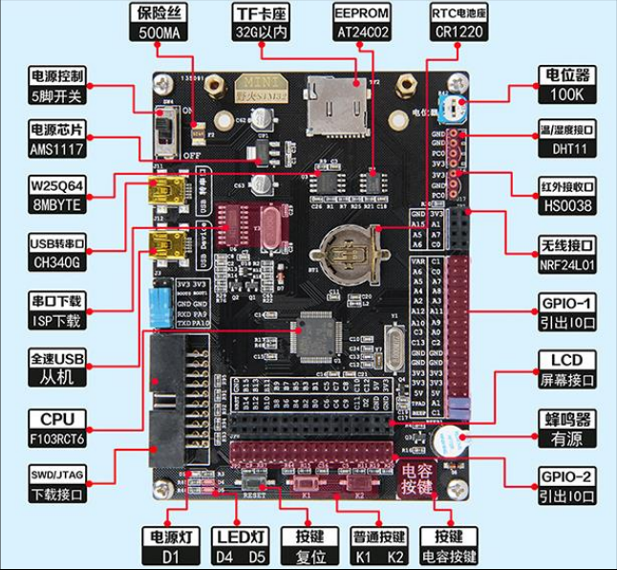

Fig 1-1 Fire[MINI] STM32F103RCT6 development board

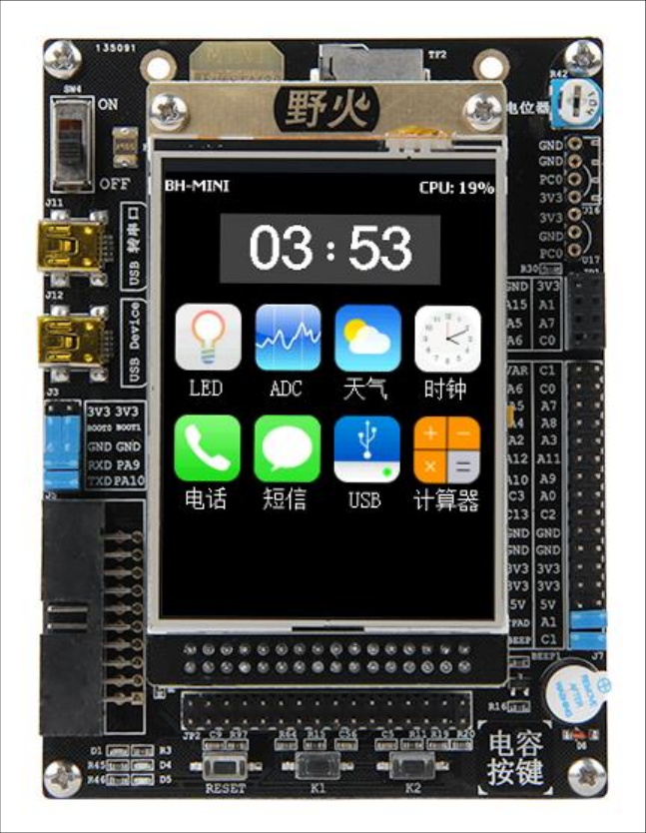

Fig 1-2 Fire[MINI] STM32F103RCT6 development board with LCD

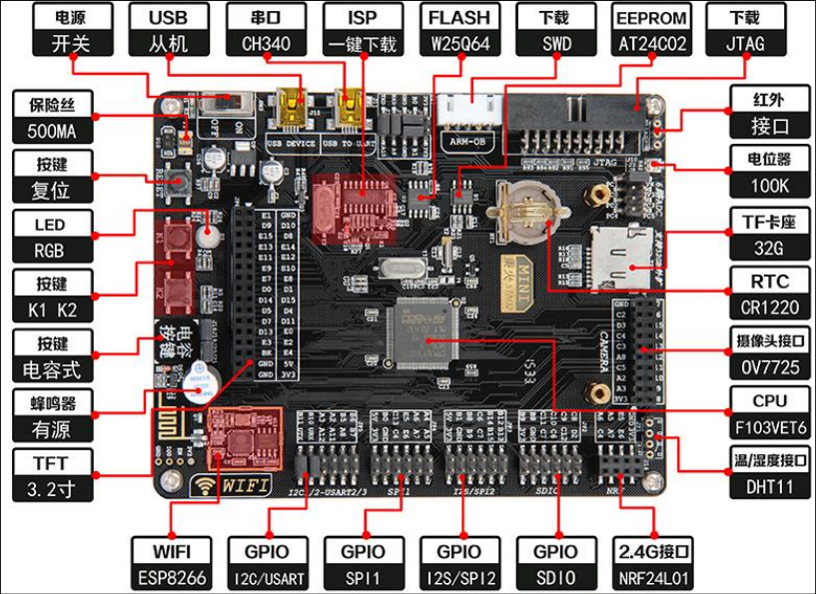

Fig 1-3 Fire[ZhiNanZhe] STM32F103VET6 development board

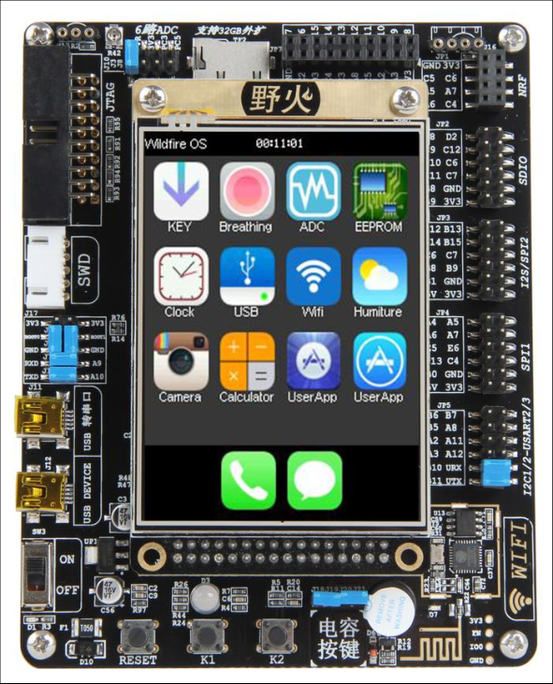

Fig 1-4 Fire[ZhiNanZhe] STM32F103VET6 development board with LCD

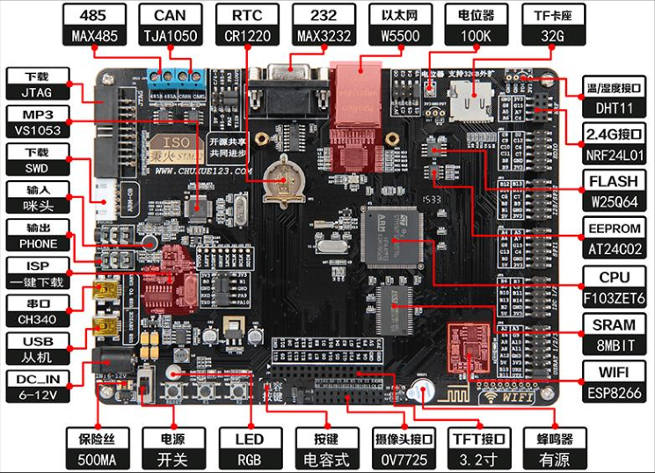

Fig 1-5 Fire[BaDao] STM32F103ZET6 development board

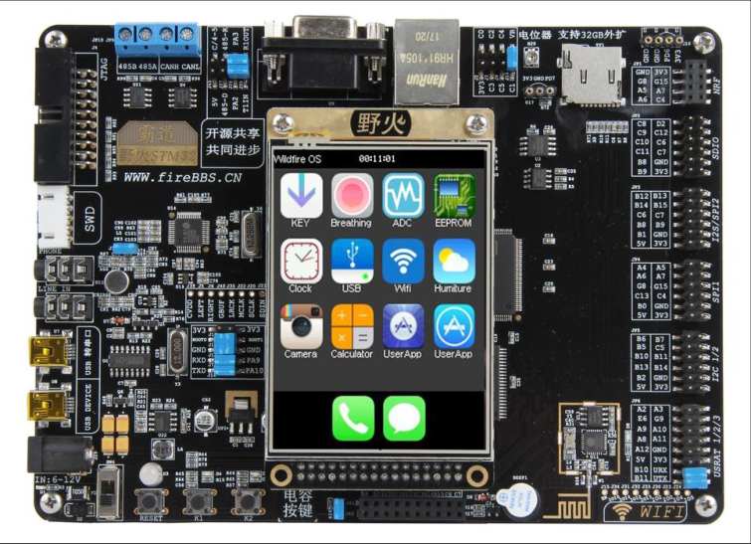

Fig 1-6 Fire[BaDao] STM32F103ZET6 development board with LCD

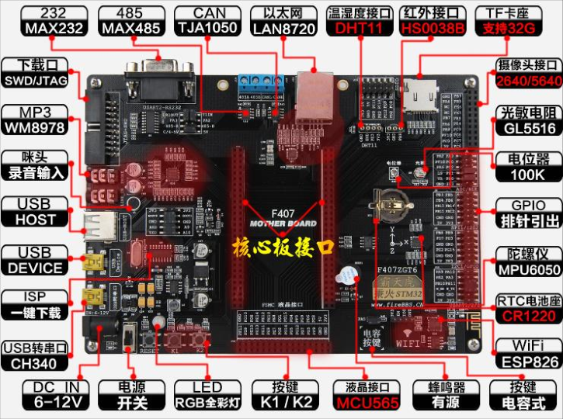

Fig 1-7 Fire[BaTianHu] STM32F407ZGT6 development board

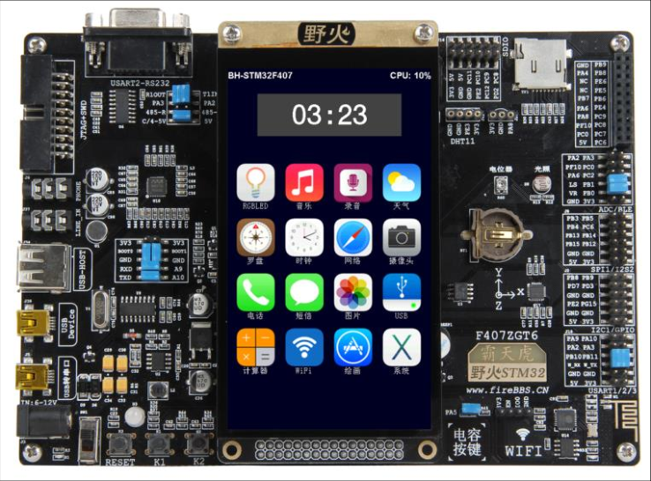

Fig 1-8 Fire[BaTianHu] STM32F407ZGT6 development board with LCD

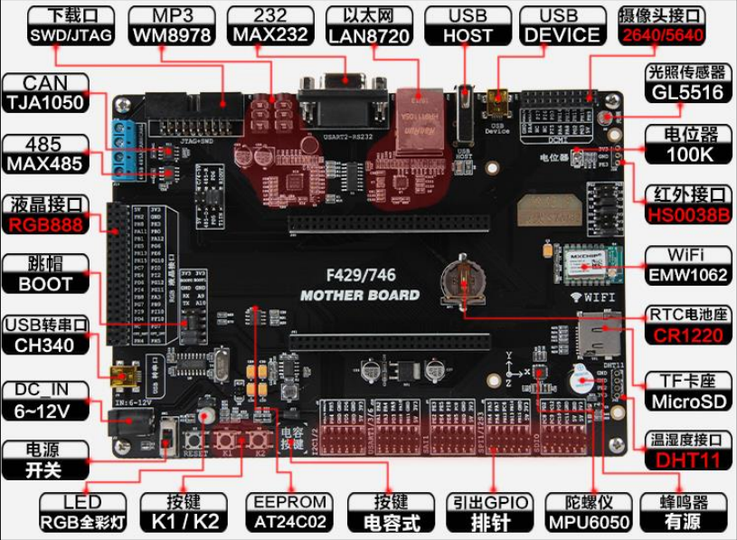

Fig 1-9 Fire[TiaoZhanZhe] F429/F767/F743development board

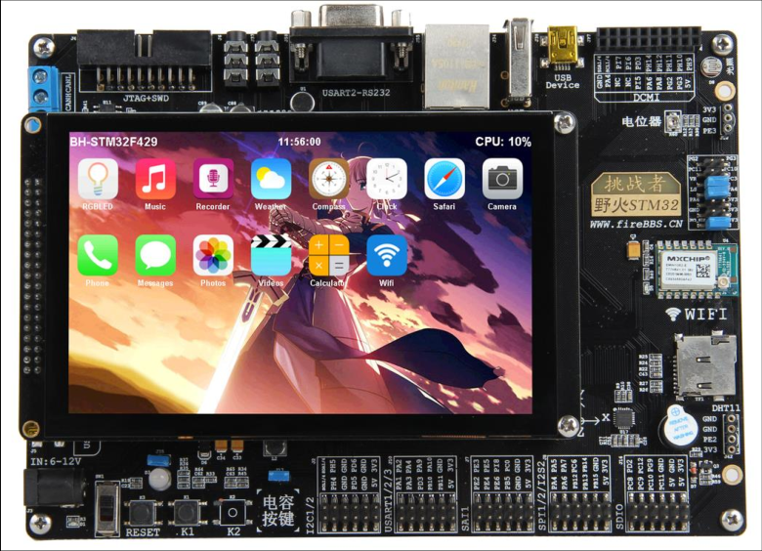

Fig 1-10 Fire[TiaoZhanZhe] F429/F767/F743development board with LCD

1.6 Technology Forum (Developer Community)

If you encounter problems in the learning process, you can go to wildfire electronic forum: www.firebbs.cn to post and exchange. Open source codes, share, and make progress together.

Considering the limited level, this book is bound to be flawed. Enthusiastic readers can also send the survey to the forum by mistake so that we can make better improvements. I wish you a happy study experience. In the RT-Thread world, wildfire will work together with you.

Ch2 How to Learn RTOS

2.1 Why Learn RTOS

When step into embedded field, the very first course we learn is MCU programming at most time, and in MCU programming, 51-core MCU is chosen as the first chip. The MCU programming we talking about here is bare machine programming, which means developing a program without any RTOS. The frequently used RTOS are μC/OS、RTX, RT-Thread、Huawei LiteOS and AliOS-Things. FreeRTOS got the highest market share due to its open source and free to use in commercial and non-commercial, but now Chinese RTOS RT-Thread has developed more than one decade, its market share is booming, and has become the NO.1 in RTOSs which are made in China.

In bare-machine system, almost all codes are coded by ourselves and all operations are executing in an infinite big loop. Many medium to small sized electronical products in our life are bare-machine system and they meet our need well. So why do we need learning programing with RTOS, bare-machine is good why a RTOS is to be added stubbornly? First reason is projects demand, as the number of functions of a given product is growing, bare-machine system can hardly address our problem perfectly, instead it may make our code more complicate. After introducing RTOS, we can use RTOS to implement multi-thread manger to decrease the system complication, and this is the biggest edge in using RTOS. Second reason is learning demand. To implement a better career planning, to make preparation for go to peek of life that marry a girl who is white, rich and beautiful, we have to learning something more advance rather than persist in bare-machine programming. As a qualified embedded engineer study should not be stopped forever, and we should prepare for our future at any moments. As a Chinese proverb says: when using knowledge then find books you have read is not enough. I wish when opportunity comes you will not have this kind of feeling.

To help readers know how to program with RTOS, we will analysis the difference between bare-machine system and RTOS system in the chapter *Bare-machine System and Multi Thread System*. The difference is called as MingMen(means key) of learning RTOS. It will make you easy to learn RTOS. We will mainly talk about method and theory when describing the two programming ways, and will not involve in concrete codes but pseudo code.

2.2 How to learn RTOS

There is some difference between bare-machine programing and RTOS programming and many people say it’s difficult to learn RTOS, so someone will feel horrible when hearing RTOS programing, and then give it up.

So how to learn a RTOS? The easiest way is conferencing the RTOS API and calling these APIs to implement the functions you want on the system others has ported. In this way we care little about how to plant a RTOS, so it is the easiest and fastest way to get started RTOS. There are both advantages and disadvantages using this way. If you are developing a product, the benefit is you can implement functions in short time and put on the market, then win the opportunity, but when meeting bugs, and you are not knowing the RTOS enough, it will makes you difficult to debug, there nothing you can do. This is its disadvantage. It is not recommended only call APIs simply in learning RTOS. We should learn one RTOS deeply.

The kernel of all of the RTOSs in market have the similar implement, so we learn one of them is enough. And it is not so difficult to use anther RTOS after you learned one deeply. How to study a RTOS in depth? Here is the most efficient but most difficult way that reading the source codes of RTOS, researching how every component implemented. The progress is dull and painful, but it will bring you great harvest. To learn the essential of RTOS, if you do not go to the hell, who will?

There are some books in the market explained the source codes of RTOS, but if you are lack of basic knowledge and haven’t the RTOS before then reading its source codes is still a dull job, and you cannot master the structure and realization of the RTOS.

Fortunately, now we take a new way to teach you one RTOS. Neither explain plainly its APIs nor analysis its source codes sentence by sentence. What we do is writing the RTOS from nothing to everything, starting from 0, step by step, improving continuous. You will feel the joy of success in every learning stage. In the process of implement RTOS, the unique knowledge you should have is basic C language skill. Following this course written by Fire, achievement is on the horizon.

2.3 Which RTOS Should be Chosen

The RTOS used to teaching, because we will not develop a RTOS by ourselves and not create wheels again, is chosen as RT-Thread which is the most popular one in China and developed by Chinese engineer. Based on RT-thread, we rewrite it from 0 to 1 step by step. During the process, we will comply with the coding styles in RT-Thread, including data type, variable name, function name, file type etc., and we will not rename any functions and variables. So that after finished this course, you can make use of RT-Thread directly without any gaps.

CH3 First acquaintance with RT-Thread

3.1 Brief introduction to RT-Thread

3.1.1 Copyright

The copyright of RT-Thread is belonging to Shanghai RT-Thread Technology Co., Ltd. The first version was released in January 2006 and its version number is 0.1.0. after more than 10 years of development, the main version number has upgraded to 4.0, The total number of developers has reached millions, and the number of devices running RT-Thread in the various of life has exceeded 20 million. RT-Thread has been the highest market share RTOS in all RTOSs made by Chinese.

3.1.2 Charge policy

RT-Thread complying with GPLv2+ opensource license is an open source and free to use RTOS. The open source we talking about here means that you can get RT-Thread source code free of charge. When RT-Thread is used in your product and you haven’t modified the RT thread kernel source code, all the code of your product can be closed source and doesn’t need to open source. But when you modified the RT thread kernel source code, you must open source the modified part and feed them back to the community. But your application code doesn’t need to open source. Free means that no matter you are an individual or a company, you can use it for free without paying a cent.

3.2 Significance of RT-Thread

I don't know whether you have found that in the field of RTOS, the real-time operations we can access are basically not from China, which is rare to have Chinese manufacturers in the RTOS field. From the hottest μC/OS in the early years to the FreeRTOS which has the highest market share today, to the RTX with the most security verification (Keil's own), to the ThreadX with the most profitability, they are all not from China. But a little over 10 years ago, in China, there was a talented, stubborn geek named Xiong PuXiang, who has compiled the first generation of RT thread kernel, and worked with the geeks in China's open source community to continuously improve and innovate. After more than 10 years of development, today, has become the leader of Chinese RTOS, hundreds of thousands of developers are growing every year. In addition, AI, the Internet of things and other outlets make RT-Thread has the potential of unifying the Jianghu(means RTOS market). From we have completed a round of multi-million dollar financing this year, we can see that in the next five years, RT thread will be the best choice for you to learn and make products.

What is the meaning of RT thread? RT thread is from China, which makes us see that Chinese technology developers can write such excellent RTOS as well, not everything is good for foreign countries. Based on our experience of more than 10 years in electronic industry, we met many Chinese developers in the past, when they saw something great, they would ask whether that was foreign or Chinese. If that was Chinese, they would ask whether that has referred to foreign countries. Many people are born with this kind of chondropathy, which is very difficult to treat. It is a natural feeling. Now RT thread is a good medicine for this kind of osteomalacia, which is the biggest significance of RT-Thread in my opinion. Of course, RT-Thread, as a Chinese Internet of things operating system, is simple, easy to use, low power design, rich components and other features will also make RT-Thread shine. Wildfire, as a Chinese embedded education brand, is also our honor to contribute to the Chinese RTOS. I hope this book can help you quickly get started and master RT-Thread.

Part one Write RT-Thread kernel from 0 to 1

The first part of this book is based on RT thread nano. It teaches you how to write RT thread from 0 step by step. This part focuses on the process of how to implement RTOS. When you finish this part, you will feel easy to use RT-Thread or other RTOS, not only knowing what it is, but also knowing why. In the process of source code implementation, the data type, variable name, function name, file name and the directory where the files are stored will all be implemented according to RT-Thread. Some unnecessary codes may be removed, but it will not affect you to understand the whole function of OS.

Each chapter of this part is the basis of the previous chapter. It is closely linked. The mystery of OS will be unveiled gradually for you. It will have a sense of openness when you read it. If you go a little further, type all the codes by yourself, and if the simulation results are the same as mine, and the sense of achievement that comes from your heart will burst. I wish you could read effortlessly. It's really worth reading. The feeling reading this book is so good that you may forget to eat. You will can't help crying out in hysteria: Brother Fire, I love you.

Ch4 Create RT-Thread Project—Software Simulation

A new project must be created before coding. Create a RT-Thread project, choose an MCU with Cortex-M3(Cortex-M4 and Cortex-M7 are ok as well) core, and set software simulation as debug mode. Then we can begin writing codes to implement RT-Thread kernel step by step, from 0 to 1. During the process, you will learn the philosophical thought of implement and design in the RT-Thread kernel. When you finished the process, it is extremely easy to port RT-Thread to another STM32 development boards, just changing a startup file and adding BSP driver codes.

4.1 Create project folder

Before starting the new project, we first create a new folder on the local computer to store the project files. The name of the folder is rtt_sw_simulation (the name can be selected at will, it’s not the key), and then each folder and file will be created under the folder. See table 4-1 for the specific contents and functions of these folders.

Table 4-1 sub folders in the root folder-rtt_sw_simulation

|  |  |  |
| --- | --- | --- |
| folder | subfolder | Function of the folder/subfolder |
| Doc | - | Some text files, such as readme.txt, project description file, compile and install commands |
| Project | - | Project files generated by MDK or other IDE. |
| rtthread/3.0.3 | bsp | Board support package, now it is empty. |
| components/finsh | the finsh component of RT-Thread, now it is empty. |
| include | Header files, now it is empty. |
| include/libc |
| libcpu/arm/cortex-m0 | Interface files related to MCU core, now it is empty. |
| libcpu/arm/cortex-m3 |
| libcpu/arm/cortex-m4 |
| libcpu/arm/cortex-m7 |
| src | Kernel source of RT-Thread, empty as well |
| User | - | Main.c and other edited by user. |

4.2 Create Keil project

The KEIL5(also called MDK5) is used as our IDE, and the version we used is 5.23, of course you can choose any version of Keil5.

4.2.1 New Project

First, run keil5, and create a new project. Place project file into the directory Project and name it Fire_RT-Thread. Of course, you can change it to another name, but it must be English rather than Chinese.

4.2.2 Select Device for Target

After inputting the name of project and clicking OK, the window named Select Device for Target will be popup, and we can select MCU in the window. ARMCM3(ARMCM4 and ARMCM7 are ok as well) is to be selected here. Illustrated in the following Fig 4-1(Fig 4-2 or Fig 4-3).

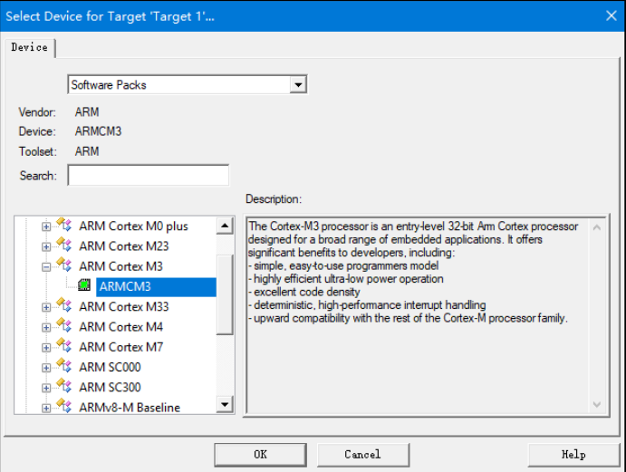

Fig 4-1 Select Device（ARMCM3） For Target

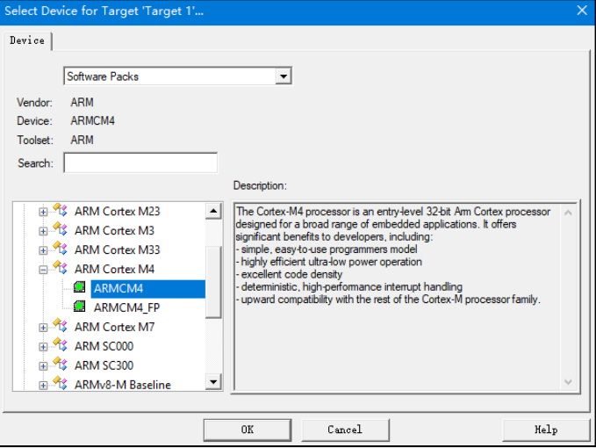

Fig 4-2 Select Device（ARMCM4） For Target

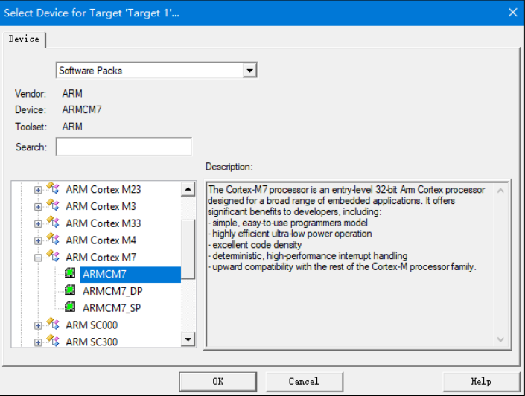

Fig 4-3 Select Device（ARMCM7）For Target

4.2.3 Manage Run-Time Environment

After MCU was selected, the window about Manage Run-Time Environment will popup, and select the two options CMSIS-Core and Device-Startup, seeing the Fig4-4.

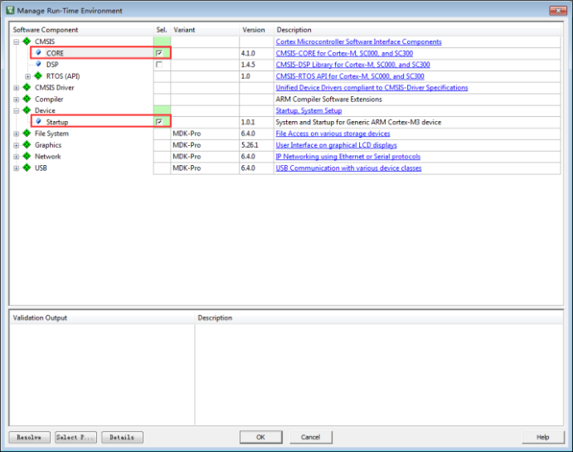

Fig 4-4 Manage Run-Time Environment

Clicking OK to close the window, the two files you selected just now has been added into project. See the Fig4-5 for detail.

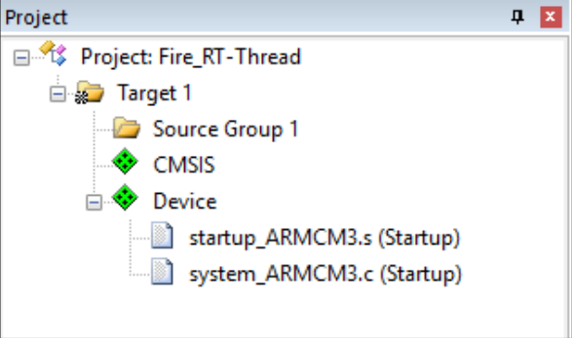

Fig 4-5 Core and Startup files

Actually, the two files are stored in the Keil installment directory, after we configured the Run-Time Environment, Keil would copy the two files to project directory: Project\RTE\Device\ARMCM3(maybe ARMCM4 or ARMCM7 ). Startup_ARMCM3.s written with assemble language is startup file, and system_ARMCM3.c written by C language is related to system clock. More specifically about these two files, you can read the source code of these two files directly. Any MCU with Cortex-M3 core will use the two files.

4.3 Creating file group in Keil Project

Adding user, rtt/ports, rtt/source and doc into the project will be helpful to mangermant. See the Fig4-6.

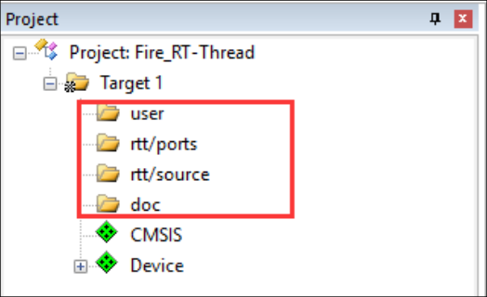

Fig 4-6 The new added file groups

How to add file groups for Keil project, it may be a problem for novices? Right click Target1 and choose Add Group in the context menu as illustrated in Fig 4-7.

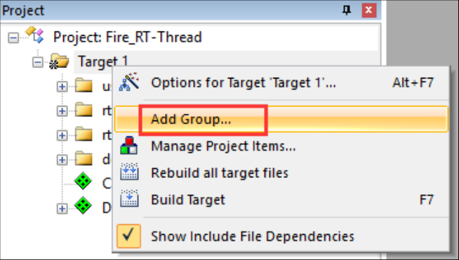

Fig 4-7 How to add file group

4.4 Add Files to Keil Project

After file groups was added to project, the next thing to do is add files to these group. Add readme.txt to group doc, add main.c to group user, and files about RT-Thread haven’t created, so, the group about RT-Thread is empty now. See Fig4-8.

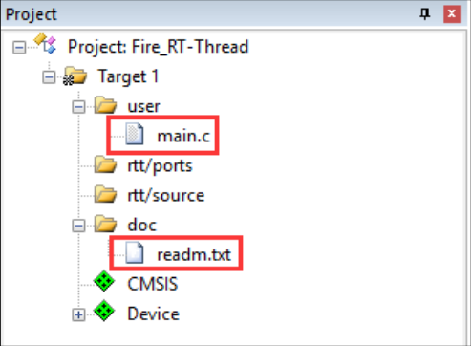

Fig4-8 files in each group

Some novices may do not know how to add file to group. Double click the group and select file in the file dialog. The default file type is set as *.c, so other files such as text and assemble file are invisible. Setting file type to All files will help you to see all files. Choose files you want to add and then click the button Add. See Fig4-9.

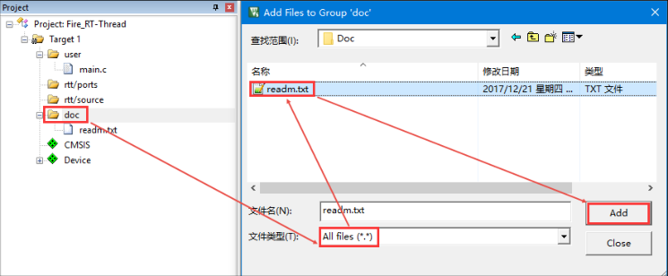

Fig4-9 add file to group

4.4.1 Writing main function

A project cannot compiled without main() function. Because the system first executes the reset program in the startup file at the beginning of execution, and the reset program will call the C library function __main. The function of __main is to initialize system variables, such as global variables, read-only, readable and writable, and so on. In the end, __main will call the __retentry, and then the main function will be called by __retentry, so that the program can run from assemble language to C codes. The main function here needs to be written manually. If the main function is not exist, there will be an undefined error of the main function.See Fig 4-10.

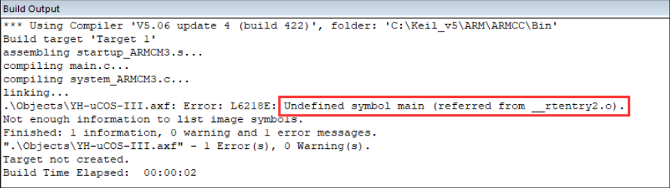

Fig4-10 Error of undefine main function

The main function is put in the file of main.c. because this is a new created project, the main function is empty now. See code List 4-1.

-------------------------------------------------------------------------------

1 /*

2 ************************************************************************

3 * main function

4 ************************************************************************

5 */

6 int main(void)

7 {

8 for (;;)

9 {

10 /* do nothing */

11 }

12 }

-------------------------------------------------------------------------------

4.5 Debug Configuration

4.5.1 Set Debug mode as Software simulation

For convenience, all our codes are simulated by software. Development board or emulator are not needed and only a Keil software is needed. See Figure 4-11 for the configuration of software simulation.

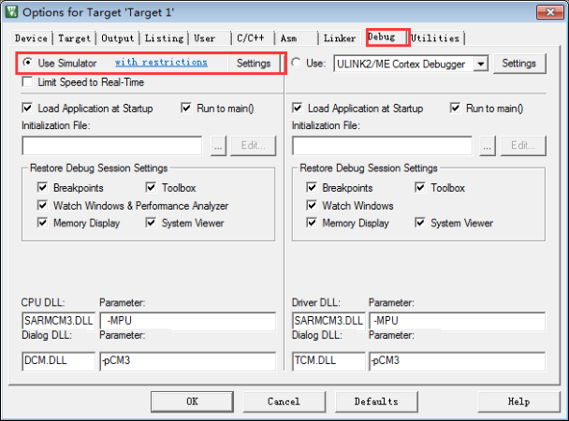

Fig4-11 configuration of software simulation

4.5.2 Modify System Clock Frequency

At the beginning of system_ARMCM3.c there is a segment of codes which defines system clock as 25MHz, see the code list 4-2. So, to ensure the accuracy of time, the clock frequency must be same as the debug configuration. So, the Xtal(Mhz) in Options for Target should be changed from the default value 12M to 25M.See Fig 4-12.

Code list 4-2

1 #define __HSI ( 8000000UL)

2 #define __XTAL ( 5000000UL)

3

4 #define __SYSTEM_CLOCK (5*__XTAL) /* 5*5000000 = 25M*/

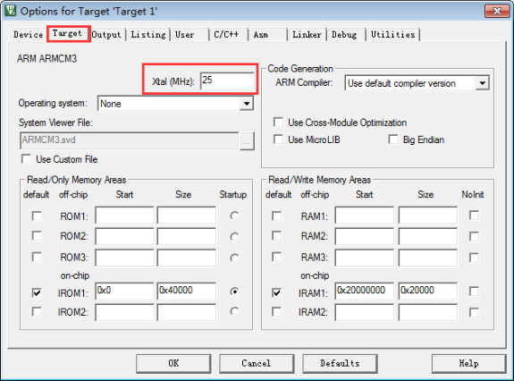

Fig4-12 Clock Setting

4.5.3 adding include path

In the C / C + + tab, specify the path of the project header file, otherwise the compilation will fail. See Fig 4-13 for the specific method of specifying the path of the header file.

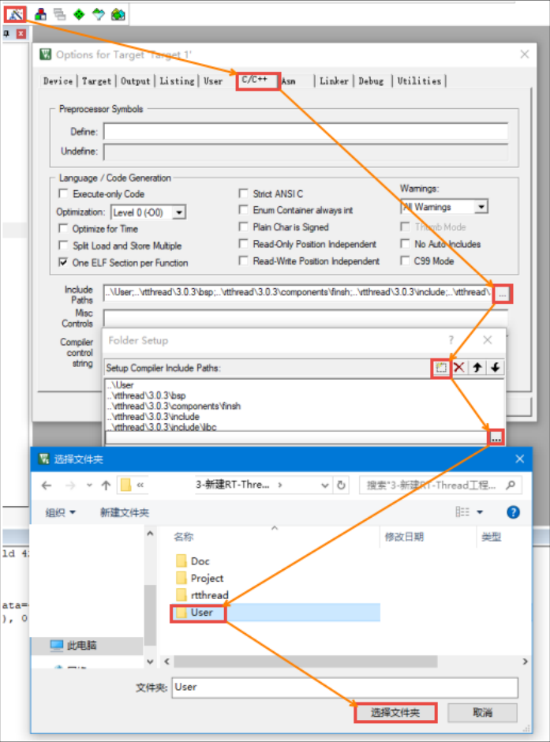

Fig4-13 Specifies the path of header files

So far, a complete RT-Thread software simulation project based on Cortex-M3 (cortex-m4 or cortex-m7) kernel has been established. Congratulations!

Ch5 Single-task system (superloop) and Multitasking System

Before writing the RTOS, let’s talk about the difference between single-task system and multitasking system. Thread and Task are synonym in RTOS.

5.1 single-task (super loop) system

Bare metal system is usually divided into polling system and front-back system. Please see the following explanation for the specific implementation of these two systems.

5.1.1 Polling system

The polling system is to initialize the relevant hardware first, and then let the main program loop continuously in a dead cycle to do various things in sequence. See code listing 5-1. Polling system is a very simple software structure, which is usually only suitable for those things that only need to execute code in sequence and do not need external events to drive. In the code listing 5-1, if only to blink LEDs, to communicate with serial port, to refresh LCD and the like, then the use of polling system will be perfect. However, if the events that need to detect external signals such as key operation are added to simulate the emergency alarm, the real-time response ability of the whole system will not be so good. Suppose that DoSomething3 is a key scan. When the key is pressed, it is equivalent to an alarm. At this time, it should have responded immediately and to do emergency processing, but now the program just executes to DoSomething1. What's more, DoSomething1 needs to be executed for a long time, even it hasn't been executed after the key is released. Then the external key event will be missed when program executes to DoSomething3. It can be seen that the polling system is only suitable for the function codes executed sequentially. When there is external event to process, the real-time performance will be reduced. As sequential processes cannot interrupt themselves, reaction times depend on the execution time of the entire sequence, resulting in a poor real-time behavior.

Code List 5-1 Pseudo code of polling system

**1 int main(void)**

**2 {**

**3 /* initialization codes of hardware */**

**4 HardWareInit();**

**5**

**6 /* infinite loop */**

**7 for (;;) {**

**8 /* do something 1 */**

**9 DoSomething1();**

**10**

**11 /* do something 2 */**

**12 DoSomething2();**

**13**

**14 /* do something 3 */**

**15 DoSomething3();**

**16 }**

**17}**

-------------------------------------------------------------------------------

5.1.2 front-back end system

Contrasting with polling system, front-back system is a polling system added interruptions, and the external events are responded in the ISR (interruption service routines) but processed in the super loop. ISR is called as front-end, and the superloop in main is called as back-end. See Pseudo codes in code list 5-2.

Code list 5-2 Pseudo codes of front-back system

**1 int flag1 = 0;**

**2 int flag2 = 0;**

**3 int flag3 = 0;**

**4**

**5 int main(void)**

**6 {**

**7 /* hardware initialization */**

**8 HardWareInit();**

**9**

**10 /* super loop */**

**11 for (;;) {**

**12 if (flag1) {**

**13 /* DoSomething 1 */**

**14 DoSomething1();**

**15 }**

**16**

**17 if (flag2) {**

**18 /* DoSomething 2 */**

**19 DoSomething2();**

**20 }**

**21**

**22 if (flag3) {**

**23 /* DoSomething 3 */**

**24 DoSomething3();**

**25 }**

**26 }**

**27 }**

**28**

**29 void ISR1(void)**

**30 {**

**31 /* set flag1 */**

**32 flag1 = 1;**

**33 /* if the event can be processed in a short time**

**34 then process it in ISR,else turn back to front-end */**

**35 DoSomething1();**

**36 }**

**37**

**38 void ISR2(void)**

**39 {**

**40 /* set flag2 */**

**41 flag2 = 1;**

**42**

**43 /* if the event can be processed in a short time**

**44 then process it in ISR,else turn back to front-end */**

**45 DoSomething2();**

**46 }**

**47**

**48 void ISR3(void)**

**49 {**

**50 /* set flag3 */**

**51 flag3 = 1;**

**52**

**53 /* if the event can be processed in a short time**

**54 then process it in ISR,else turn back to front-end */**

**55 DoSomething3();**

**56 }**

When executing the background program, if there is an interrupt occurred, the interrupt will interrupt the normal execution flow of the background program, and execute the interrupt service program instead. Set the event flag in the ISR. If the event can be handled in a short time, it will be handled in ISR, else handle it in foreground program. Although the event response and processing are separated, the event processing is performed in the background in sequence, comparing with the polling system, the front-back end systems ensures that the event will not be lost, and the interrupt can be nested, which can greatly improve the real-time response ability of the program. In most small and medium-sized projects, if the front-back systems are well used, it will be as good as RTOS.

5.2 Multitasking (Multithread) System

Compared with the front and back systems, the event response of the multithread system is also in ISR, but the event processing is completed in the thread. In a multithread system, every thread has its own priority, and thread with higher priority will be executed first. When an event flag of emergency event is marked the ISR, if the priority of the thread corresponding to the event is high enough, it will be responded immediately. Compared with the front and back system, the real-time ability of multithread system is improved again. See code listing 5-3 for the pseudo code of multithread system.

Code list 5-3 pseudo code of multithread system

**1 int flag1 = 0;**

**2 int flag2 = 0;**

**3 int flag3 = 0;**

**4**

**5 int main(void)**

**6 {**

**7 /* initialization codes of hardeware */**

**8 HardWareInit();**

**9**

**10 /* OS initialization */**

**11 RTOSInit();**

**12**

**13 /* start OS,begining mulitithread schedule,don't return */**

**14 RTOSStart();**

**15 }**

**16**

**17 void ISR1(void)**

**18 {**

**19 /* set flag */**

**20 flag1 = 1;**

**21 }**

**22**

**23 void ISR2(void)**

**24 {**

**25 /* set flag */**

**26 flag2 = 2;**

**27 }**

**28**

**29 void ISR3(void)**

**30 {**

**31 /* set flag */**

**32 flag3 = 1;**

**33 }**

**34**

**35 void DoSomething1(void)**

**36 {**

**37 /* infinite loop,should not return */**

**38 for (;;) {**

**39 /* thread instance */**

**40 if (flag1) {**

**41**

**42 }**

**43 }**

**44 }**

**45**

**46 void DoSomething2(void)**

**47 {**

**48 /* infinite loop,should not return */**

**49 for (;;) {**

**50 /* thread instance */**

**51 if (flag2) {**

**52**

**53 }**

**54 }**

**55 }**

**56**

**57 void DoSomething3(void)**

**58 {**

**59 /* infinite loop,should not return */**

**60 for (;;) {**

**61 /* thread instance */**

**62 if (flag3) {**

**63**

**64 }**

**65 }**

**66 }**

Compared with the program body executed in the background in the front-back system, in the multithread system, according to the functions of the program, we divide the program body into some independent, infinite loop and non-returnable small programs, which we call threads. Each thread is independent, non-interference, and has its own priority, which is scheduled and managed by the operating system. After joining the operating system, we don't need to design the execution flow of the program meticulously, and we don't need to worry about whether there is interference between each function module. With the addition of the operating system, our programming has become simpler. The additional overhead of RTOS is the little flash and ram occupied. With the developing of MCU, the FLASH and RAM size is getting bigger, the flash and ram occupied by RTOS can be ignored.

Whether it's polling system, front-back end system and multithreading system, we can't decide which is better or worse. They are products of different eras and have considerable application value in their respective fields. Only suitable one is the best one. See Table 5-1 for the differences between the three software models.

Table 5-1 differences between polling, front-back end and RTOS system

|  |  |  |  |
| --- | --- | --- | --- |
| Software models | Event response | Event processing | Feature about event |
| Polling system | Main function | Main function | Response in polling, processing in polling |
| front-back end System | ISR | Main function | Response in real time, processing in polling |
| Multithread system | ISR | ISR | Response in real time, processing in real time |

Ch6 The definition of thread and the implementation of thread switch

6.1 Objective of this chapter

This chapter is the first chapter to implement RT-Thread from 0 to 1. It is the foundation of the foundation. Creating threads and how to switch threads must be focused on. Because the thread switching is implemented by assemble language which is difficult to understand, I will try my best to explain the code thoroughly. If the content of this chapter can't be understood, let alone the following.

Two threads will be created in this chapter, and switch between them. The main body of the thread is to turn a variable according to a certain frequency. Through the software simulation function of KEIL, observe the change of variable waveform in the logic analyzer. See Figure 6-1 for the final waveform diagram.

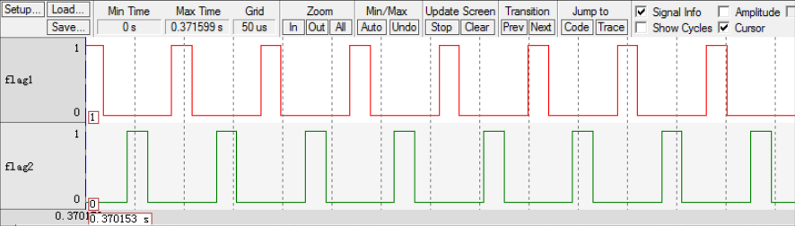Fig6-1 Simulation waveform

Actually, the function of Fig6-1 can be implemented without RTOS as well. See code list 6-1.

Code list 6-1 two variables flip in turn in bare metal system

**1 /* To observe flag in logic analyzer, flags must be global variable**

**2 * and set logic analyzer as bit mode**

**3 */**

**4 uint32_t flag1;**

**5 uint32_t flag2;**

**6**

**7**

**8 /* delay sometime by software */**

**9 void delay( uint32_t count )**

**10 {**

**11 for (; count!=0; count--);**

**12 }**

**13**

**14 int main(void)**

**15 {**

**16 /*super loop */**

**17 for (;;) {**

**18 flag1 = 1;**

**19 delay( 100 );**

**20 flag1 = 0;**

**21 delay( 100 );**

**22**

**23 flag2 = 1;**

**24 delay( 100 );**

**25 flag2 = 0;**

**26 delay( 100 );**

**27 }**

**28 }**

In a multithreaded system, the effect chart of two threads continuously switching should be as shown in Figure 6-2, that is, the waveforms of two variables are exactly the same, just like the CPU is doing two things at the same time, which is the meaning of multithreading. Although the two waveforms are the same, the implementation code are totally different, from the original sequential execution to the thread switching, which is the fundamental difference. This chapter is just the beginning about how to switch threads, and must be mastered. In the following chapters, the functional code will be gradually improved, joining the system scheduling, and implementing the real multithreading. This chapter is just a beginning and don’t worry.

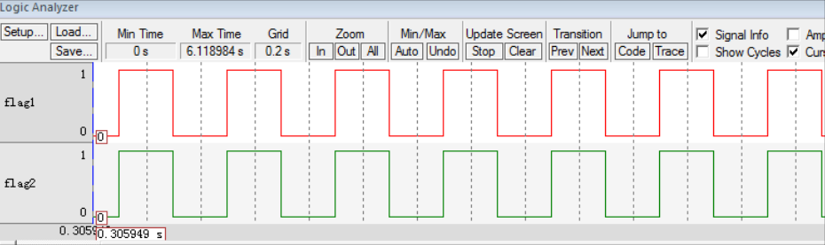

Fig 6-2 Rendering of multi threads switching

6-2 What is a thread

In the bare metal system, the main body of the system is the infinite loop executed in sequence in the main function, in which the CPU processes all kinds of things in order. In a multithreaded system, the whole system is divided into some independent and unreturned functions according to functions. This function is called thread. See code listing 6-2 for the approximate form of thread function.

Code list 6-2 The form of a thread in the multithread system.

**1 void thread_entry (void *parg)**

**2 {**

**3 /* thread body,infinite loop and non-return */**

**4 for (;;) {**

**5 /* codes of thread body*/**

**6 }**

**7 }**

6.3 Thread Creation

6.3.1 Definition of Thread Stack

In a bare metal system, if there are global variables, subfunction calling and interrupts. Then, when the system is running, where is the global variable, where is the local variable when the subfunction is called, and where is the function return address when the interrupt occurs? If it's just bare metal programming, the place where they stored can be ignored, but to write an RTOS, how and where these various environment parameters are stored must clearly. In the bare metal system, they are all placed in a place called stack. The stack is a continuous memory space in the ram MCU. The size of the stack is generally specified in the startup file or link script, and finally initialized by the C library function _main.

However, in a multithreaded system, each thread is independent and does not interfere with each other, so an independent stack space should be allocated for each thread. This stack space is usually a pre-defined global array or a dynamically allocated memory space, but they all exist in RAM.

In this chapter, the rotation of two variables according to a certain frequency will be implement. Each variable corresponds to a thread and two thread stacks should be defined. See code listing 6-3 for details. In a multithreaded system, you need to define as many thread stacks as the number of threads.

Code list 6-3 definition of thread stack

**1 ALIGN(RT_ALIGN_SIZE) (2)**

**2 /* define thread stack */**

**3 rt_uint8_t rt_flag1_thread_stack[512]; (1)**

**4 rt_uint8_t rt_flag2_thread_stack[512];**

Code listing 6-3 (1): the thread stack is actually a pre-defined global array with the data type of **rt_uint8_t**, and its size is 512. RT-Thread redefine the stand data type in C language by typedef to new type with prefix rt_ in the file redef.h(the first use of rtdef.h needs to be created under the include folder and then added to the project RTT/source group file). See code listing 6-4 for details. In code listing 6-4, besides **rt_uint8_t**, other data type redefinitions need to be used later in this chapter. They will be pasted here and will not be described later.

Code list 6-4 rtredef.h

**1 #ifndef __RT_DEF_H__**

**2 #define __RT_DEF_H__**

**3**

**4 /\***

**5 \*\*\*\*\*\*\*\*\*\*\*\*\*\*\*\*\*\*\*\*\*\*\*\*\*\*\*\*\*\*\*\*\*\*\*\*\*\*\*\*\*\*\*\*\*\*\*\*\*\*\*\*\*\*\*\*\*\*\*\*\*\*\*\*\*\*\***

**6 * data type**

**7 \*\*\*\*\*\*\*\*\*\*\*\*\*\*\*\*\*\*\*\*\*\*\*\*\*\*\*\*\*\*\*\*\*\*\*\*\*\*\*\*\*\*\*\*\*\*\*\*\*\*\*\*\*\*\*\*\*\*\*\*\*\*\*\*\*\*\***

**8 */**

**9 /* redefinition of base data type in RT-Thread*/**

**10 typedef signed char rt_int8_t;**

**11 typedef signed short rt_int16_t;**

**12 typedef signed long rt_int32_t;**

**13 typedef unsigned char rt_uint8_t;**

**14 typedef unsigned short rt_uint16_t;**

**15 typedef unsigned long rt_uint32_t;**

**16 typedef int rt_bool_t;**

**17**

**18 /* 32bit CPU */**

**19 typedef long rt_base_t;**

**20 typedef unsigned long rt_ubase_t;**

**21**

**22 typedef rt_base_t rt_err_t;**

**23 typedef rt_uint32_t rt_time_t;**

**24 typedef rt_uint32_t rt_tick_t;**

**25 typedef rt_base_t rt_flag_t;**

**26 typedef rt_ubase_t rt_size_t;**

**27 typedef rt_ubase_t rt_dev_t;**

**28 typedef rt_base_t rt_off_t;**

**29**

**30 /* boolean type */**

**31 #define RT_TRUE 1**

**32 #define RT_FALSE 0**

**33**

**34 #ifdef __CC_ARM**

**35 #define rt_inline static __inline**

**36 #define ALIGN(n) __attribute__((aligned(n)))**

**37**

**38 #elif defined (__IAR_SYSTEMS_ICC__)**

**39 #define rt_inline static inline**

**40 #define ALIGN(n) PRAGMA(data_alignment=n)**

**41**

**42 #elif defined (__GNUC__)**

**43 #define rt_inline static __inline**

**44 #define ALIGN(n) __attribute__((aligned(n)))**

**45 #else**

**46 #error not supported tool chain**

**47 #endif**

**48**

**49**

**50 #define RT_ALIGN(size, align) (((size) + (align) - 1)** & **~((align) - 1))**

**51 #define RT_ALIGN_DOWN(size, align) ((size)** & **~((align) - 1))**

**52**

**53**

**54 #define RT_NULL (0)**

**55**

**56 #endif /* __RT_DEF_H__ */**

Listing 6-3 (2): set how many bytes a variable needs to be aligned to work on the variables below it. ALIGN is a macro with parameters defined in rtdef.h. See code listing 6-4 for details. RT_ALIGN_SIZE is a macro defined in rtconfig.h (the first time rtconfig.h is used, it needs to be created under the user folder and then added to the project user group file). The default value is 4, which means four bytes are aligned. See code listing 6-5 for details.

Code list 6-5 Macro RT_ALIGN_SIZE

**1 #ifndef __RTTHREAD_CFG_H__**

**2 #define __RTTHREAD_CFG_H__**

**3**

**4 #define RT_ALIGN_SIZE 4 /* Aligned in how many bytes */**

**5**

**6**

**7 #endif /* __RTTHREAD_CFG_H__ */**

6.3.2 definition of thread function

Thread is an independent function. The body of the function is infinite and nonreturn. Two threads are defined in main.c. See code list 6-6

Code list 6-6 Thread function

**1 /* software delay */**

**2 void delay (uint32_t count)**

**3 {**

**4 for (; count!=0; count--);**

**5 }**

**6**

**7 /* thread 1 */**

**8 void flag1_thread_entry( void *p_arg ) (1)**

**9 {**

**10 for ( ;; )**

**11 {**

**12 flag1 = 1;**

**13 delay( 100 );**

**14 flag1 = 0;**

**15 delay( 100 );**

**16 }**

**17 }**

**18**

**19 /* thread 2 */**

**20 void flag2_thread_entry( void *p_arg ) (2)**

**21 {**

**22 for ( ;; )**

**23 {**

**24 flag2 = 1;**

**25 delay( 100 );**

**26 flag2 = 0;**

**27 delay( 100 );**

**28 }**

**29 }**

Noting the (1) and (2) in code list 6-6, as said before, thread is an independent, infinite loop function that cannot be returned.

6.3.3 Definition of Thread Control Block

In a bare metal system, the body of the program is executed sequentially by the CPU. In multithreaded systems, thread execution is scheduled by operation system. In order to schedule the thread smoothly, the system defines an additional thread control block for each thread, which is equivalent to the thread's ID card, which contains all the information about the thread, such as the thread's stack pointer, thread name, thread parameters, etc. With this thread control block, all the system's operations on the thread can be achieved through this thread control block. Defining a thread control block requires a new data type, which is declared in the header file of rtdef.h, as detailed in code listing 6-7, which can be used to define a thread control block instance for each thread.

Code listing 6-7 Thread control block type declaration

**1 struct rt_thread (1)**

**2 {**

**3 void *sp; /* pointer of thread stack */**

**4 void *entry; /* entry address of thread */**

**5 void *parameter; /* parameter to thread */**

**6 void *stack_addr; /* start address of thread stack */**

**7 rt_uint32_t stack_size; /* stack size,measured in byte */**

**8 };**

**9 typedef struct rt_thread *rt_thread_t; (2)**

Code Listing 6-7 (1): There are still fewer members in the thread-controlled block structure, and we'll slowly add members in it later.

Code Listing 6-7 (2): In RT-Thread, a pointer is redefined for the newly declared data structure. Later, if you want to define a thread control block variable, you use the form of struct rt_thread xxx, and the definition of a thread control block pointer uses the form of rt_thread_t xxx.

In this chapter, two thread control blocks are defined for two threads in the file main.c, as detailed in code listing6-8.

Code listing 6-8 definition of Thread control block

**1 /* definition of tread control block */**

**2 struct rt_thread rt_flag1_thread;**

**3 struct rt_thread rt_flag2_thread;**

6.3.4 Implement thread creation functions

The thread's stack, the thread's function entity and the thread's control block eventually need to be connected in order to the system can schedule threads unified. Then the work of this association is done by the thread initialization function rt_thread_init(), which is defined in the thread.c (thread.c first used and needs to be created in the folder rtthread/3.0.3/src and added to the project's rtt/source group), declared in rtthread.h, all thread-related functions are defined in this file.The implementation of the rt_thread_init() function can be found in Code Listing 6-9.

Code Listing 6-9 Function of rt_rhread_init

**1 rt_err_t rt_thread_init(struct rt_thread *thread, (1)**

**2 void (*entry)(void *parameter), (2)**

**3 void *parameter, (3)**

**4 void *stack_start, (4)**

**5 rt_uint32_t stack_size) (5)**

**6 {**

**7 rt_list_init(**&(**thread->tlist)); (6)**

**8**

**9 thread->entry = (void *)entry; (7)**

**10 thread->parameter = parameter; (8)**

**11**

**12 thread->stack_addr = stack_start; (9)**

**13 thread->stack_size = stack_size; (10)**

**14**

**15 /* initialize thread stack and return the stack pointer */ (11)**

**16 thread->sp =**

**17 (void *)rt_hw_stack_init( thread->entry,**

**18 thread->parameter,**

**19 (void *)((char *)thread->stack_addr + thread->stack_size - 4) );**

**20**

**21 return RT_EOK; (12)**

**22 }**

Code Listing 6-9: rt_thread_init function follows the function naming rules in RT-Thread, starting with lowercase rt, indicating that this is an external function that can be called by a user and represents an internal function that begins with a _rt and can only be used internally by RT-Thread. Next is the file name, which file the function is placed in, and finally the function feature name.

Code Listing 6-9 (1): pointer of the thread control block.

Code Listing 6-9 (2): Entry is the name of the thread function, representing the entry of the thread.

Code listing6-9 (3) : thread parameter that passes thread parameters.

Code Listing 6-9 (4): stack_start used to point to the starting address of the thread stack.

Code Listing 6-9 (5): stack_size represents the size of the thread stack in bytes.

1 Implement list-related functions

Code List 6-9 (6): Initialize the thread list node, and then the thread will be inserted into various of list with this node, it is like a hook hanging thread control block to various of lists. Before initialization, a thread list node should be added to the thread control block, as detailed in the bold part of the code list 6-10.

Code listing 6-10 add thread list node to thread control block

**1 struct rt_thread**

**2 {**

**3 void *sp; /* pointer of thread pointer */**

**4 void *entry; /* entry address of thread */**

**5 void *parameter; /* thread parameter */**

**6 void *stack_addr; /* start address of thread stack */**

**7 rt_uint32_t stack_size; /* size of thread stack, measured in bytes */**

**8**

**9 rt_list_t tlist; /* node of thread list */ (1)**

**10};**

Code listing 6-10(1):the type of tlist is rt_list_t, which is defined in file rtdef.h, seeing code listing 6-11 for detail.

Definition the data type of link node

Code list 6-11 The definition of type rt_list_t .

**1 struct rt_list_node**

**2 {**

**3 struct rt_list_node *next; /* pointer to next node */**

**4 struct rt_list_node *prev; /* pointer to previous node */**

**5 };**

**6 typedef struct rt_list_node rt_list_t;**

rt_list_t type nodes have two pointers of rt_list_t type, next and prev, to point to the next node in the list and the previous node, respectively. A dual-link list consisting of nodes of the rt_list_t type represents as figure 6-3.

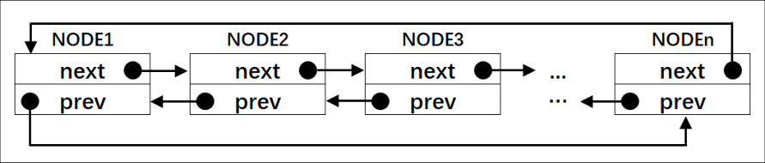

Fig 6-3 dual-link list constructed with rt_list_t

The functions related to dual-link list are defined in file reservices.h. This is the first time we use rtservice.h,it should be created under the rtthread/3.0.3/include folder and then added to the project's rtt/source group.

Initialize List Node

The initialization of node with rt_list_t type is just set the next and prev pointer pointer to the node itself. See code listing 6-12 and Fig6-4.

Code listing 6-12 initialization of Node

**1 rt_inline void rt_list_init(rt_list_t *l)**

**2 {**

**3 l->next = l->prev = l;**

**4 }**

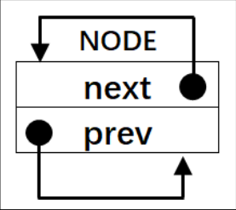

Fig 6-4 an initialized rt_thread_t node

Insert a node after header in dual-link list

Code listing 6-12 showed how to insert a node after head node, It is split into 4 steps . The list state before and after insertion are illustrated in Fig6-5

Code listing 6-12 insert a node after head node

**1 /* insert a node after head node */**

**2 rt_inline void rt_list_insert_after(rt_list_t *l, rt_list_t *n)**

**3 {**

**4 l->next->prev = n; /* step ① */**

**5 n->next = l->next; /* step ② */**

**6**

**7 l->next = n; /* step ③ */**

**8 n->prev = l; /* step ④ */**

**9 }**

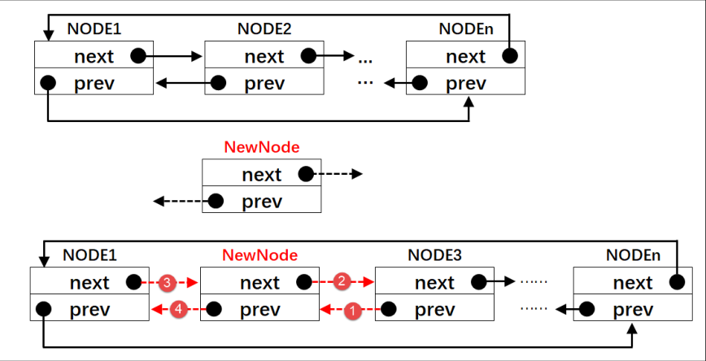

Fig 6-5 How to insert a node after head node

Insert a node before header list

To insert a node before the head node showed in code listing 6-14, also split into 4 steps, and Fig 6-6 illustrated how it works.

Code listing 6-14 Insert a node before header list

**1 rt_inline void rt_list_insert_before(rt_list_t *l, rt_list_t *n)**

**2 {**

**3 l->prev->next = n; /* step ① */**

**4 n->prev = l->prev; /* step ② */**

**5**

**6 l->prev = n; /* step ③ */**

**7 n->next = l; /* step ④ */**

**8 }**

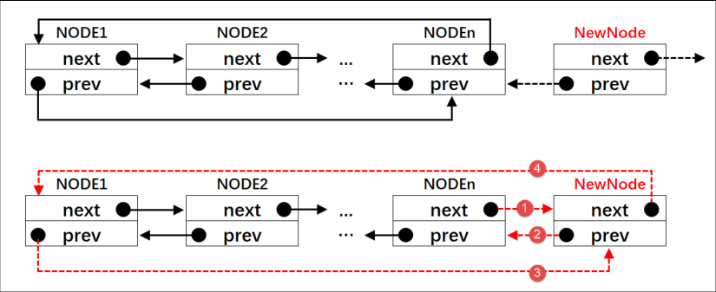

Fig 6-6 how to insert a node before list header

Delete a node from a dual-link list

Code listing 6-15 shows how to delete a node from a dual-link list by 3 step, and Fig 6-7 shows how to do it.

Code listing 6-15 delete a node from dual-link list

**1 rt_inline void rt_list_remove(rt_list_t *n)**

**2 {**

**3 n->next->prev = n->prev; /* step ① */**

**4 n->prev->next = n->next; /* step ② */**

**5**

**6 n->next = n->prev = n; /* step ③ */**

**7 }**

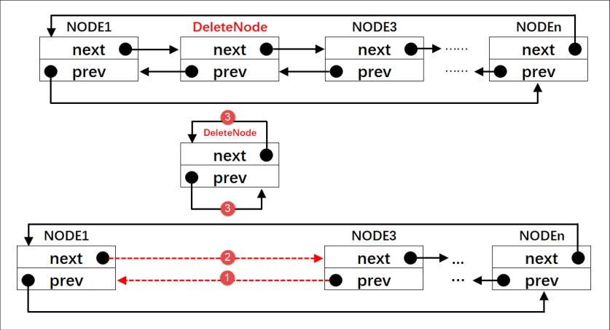

Fig 6-7 how to delete node from dual-link list

Code Listing 6-9 (7): Save the thread entry to the entry member of the thread control block.

Code Listing 6-9 (8): Save the thread inlet parameter to the parameter member of the thread control block.

Code Listing 6-9 (9): Save the thread stack start address to a stack_start member of the thread control block.

Code Listing 6-9 (10): Save the thread stack size to a member of the stack_size of the thread control block.

Code Listing 6-9 (11): Initialize the thread stack and return the top pointer of the thread stack. rt_hw_stack_init () is used to initialize the thread stack, and when the thread first runs, the parameters loaded into the CPU register are placed in the thread stack, which is implemented in cpuport.c, as shown in code listing6-16. cpuport.c is the first using it which needs to be created under the rtthread/3.0.3/libcpu/arm/cortex-m3 (cortex-m4 or cortex-m7) folder and then added to the project's rtt/ports group.

2 function rt_hw_stack_init()

Code listing 6-16 function rt_hw_stack_init()

1 rt_uint8_t **\***rt_hw_stack_init**(**void **\***tentry**,** **(**1**)**

2 void **\***parameter**,** **(**2**)**

3 rt_uint8_t **\***stack_addr**)** **(**3**)**

4 **{**

5

6

7 struct stack_frame **\***stack_frame**;** **(**4**)**

8 rt_uint8_t **\***stk**;**

9 unsigned long i**;**

10

11

12 /* get the pointer of stack top

13 when calling rt_hw_stack_init, stack_addr is stack top -4*/

14 stk **=** stack_addr **+** **sizeof(**rt_uint32_t**);** **(**5**)**

15

16 /* set stk */

17 stk **=** **(**rt_uint8_t **\*)**RT_ALIGN_DOWN**((**rt_uint32_t**)**stk**,** 8**);** **(**6**)**

18

19 /* move stk down by sizeof(struct stack_frame) */

20 stk **-=** **sizeof(**struct stack_frame**);** **(**7**)**

21

22 /* save stk to stack_frame */

23 stack_frame **=** **(**struct stack_frame **\*)**stk**;** **(**8**)**

24

25 /* set the content as 0xdeadbeef from stack_frame to

26 stack_frame + sizeof(struct stack_frame) */

27 **for** **(**i **=** 0**;** i **<** **sizeof(**struct stack_frame**)** **/** **sizeof(**rt_uint32_t**);** i **++)** **(**9**)**

28 **{**

29 **((**rt_uint32_t **\*)**stack_frame**)[**i**]** **=** 0xdeadbeef**;**

30 **}**

31

32 /* initialize exception register */ **(**10**)**

33 stack_frame**->**exception_stack_frame**.**r0 **=** **(**unsigned long**)**parameter**;** /* r0 : argument */

34 stack_frame**->**exception_stack_frame**.**r1 **=** 0**;** /* r1 */

35 stack_frame**->**exception_stack_frame**.**r2 **=** 0**;** /* r2 */

36 stack_frame**->**exception_stack_frame**.**r3 **=** 0**;** /* r3 */

37 stack_frame**->**exception_stack_frame**.**r12 **=** 0**;** /* r12 */

38 stack_frame**->**exception_stack_frame**.**lr **=** 0**;** /* lr */

39 stack_frame**->**exception_stack_frame**.**pc **=** **(**unsigned long**)**tentry**;** /* entry point, pc */

40 stack_frame**->**exception_stack_frame**.**psr **=** 0x01000000L**;** /* PSR */

41

42

43 /* return the pointer of thread stack */

44 **return** stk**;** **(**11**)**

45 **}**

Code Listing 6-16 (1): Thread entry.

Code Listing 6-16 (2): Threaded parameters.

Code Listing 6-16 (3): Thread stack top address-4, which is passed in at the time of the function call is the top address of the thread stack-to-4.

Code Listing 6-16 (4): Defines a structure stack_frame pointer of the stack_frame type of struct, which is defined in cpuport.c, as detailed in code listing 6-17.

Code listing 6-17 definition of struct stack_frame

1 struct exception_stack_frame

2 **{**

3 /* once exception occurred, these will be loaded to CPU register automatically */

4 rt_uint32_t r0**;**

5 rt_uint32_t r1**;**

6 rt_uint32_t r2**;**

7 rt_uint32_t r3**;**

8 rt_uint32_t r12**;**

9 rt_uint32_t lr**;**

10 rt_uint32_t pc**;**

11 rt_uint32_t psr**;**

12 **};**

13

14 struct stack_frame

15 **{**

16 /* once exception occurred, these will be loaded to CPU register by manual */

17 rt_uint32_t r4**;**

18 rt_uint32_t r5**;**

19 rt_uint32_t r6**;**

20 rt_uint32_t r7**;**

21 rt_uint32_t r8**;**

22 rt_uint32_t r9**;**

23 rt_uint32_t r10**;**

24 rt_uint32_t r11**;**

25

26 struct exception_stack_frame exception_stack_frame**;**

27 **};**

Code listing 6-16(5),getting the address of stack top and assign it to pointer variable stk. When calling rt_hw_stack_init() in rt_thread_init (), the parameter passed to stack_addr is the stack top address minus 4, so, let add sizeof(rt_uint32_t) to it and then stk will point to the top of stack.

Code listing 6-16(6), align the stk pointer down to 8 bytes, ensuring that the stk is an 8-byte aligned address. In MCU with cortex-M3, M4 or M7 core, the bus width is 32 bits, so, the stack aligned with 4-bytes is enough. But sometimes when do float-point operations the stack should be aligned with 8-bytes. If the top pointer is 8 bytes aligned, when aligning down 8 bytes, the pointer will do not move, if not 8 bytes aligned, when aligning down 8 bytes, it will skip a few bytes that will not be used. For example, when the stk is 33, obviously cannot be divided by 8, down 8 bytes alignment is 32, then a byte will be skip and not to use.

Code listing 6-16(7), the stk pointer continues to move down the sizeof (struct stack_frame) offset, which is the size of 16 words. If the top pointer is initially 8-byte aligned, then the stk now points to figure 6-8 in the thread stack.

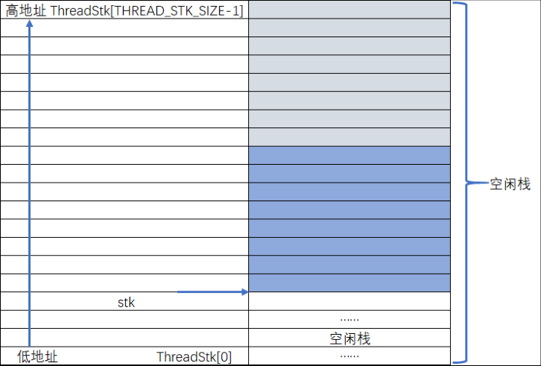

Fig 6-8 stk pointer

Code listing 6-16(8), the stk pointer is forced into a stack_frame type and then stored in the pointer variable stack_frame, at which point stack_frame in the thread stack specifically see Figure 6-9.

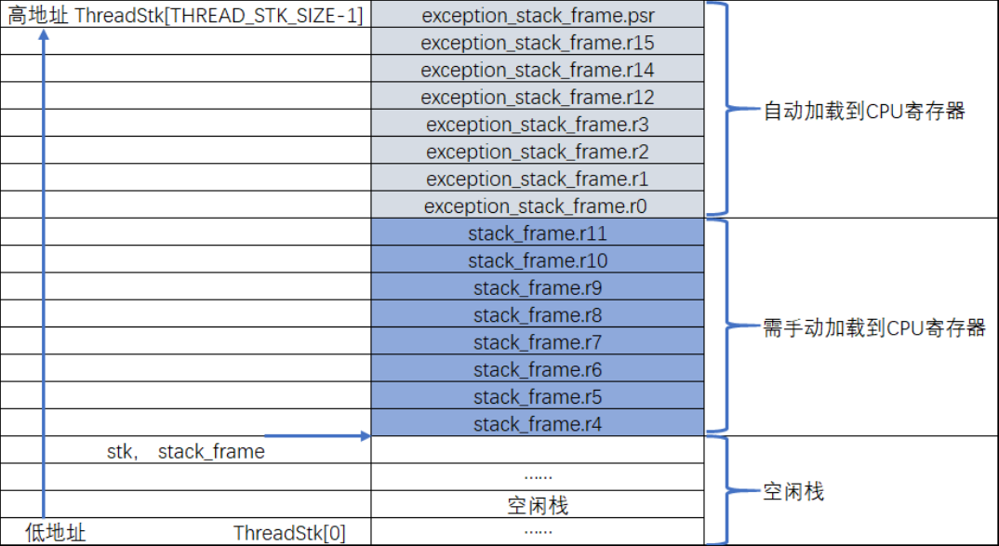

Figure 6-9 where stack_frame point to

Code listing 6-16(9), with the stack_frame as the starting address, the sizeof (struct stack_frame) memory in the stack space is initialized to 0xdeadbeef, and the content distribution of the stack space is specifically shown in Fig 6-10.

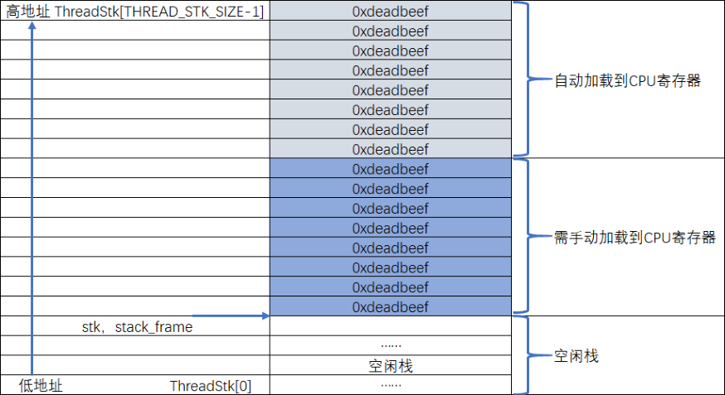

Fig 6-10 content in the stack space before initialization

Code listing 6-16(10), the first time the thread runs, the environment parameters that are loaded into the CPU register should have been initialized. Starting at the top of the stack, the order of initialization is fixed, starting with the eight registers namely xPSR, R15, R14, R12, R3, R2, R1, and R0 that are automatically saved when the exception occurs. Where the bit 24 of the xPSR register must be 1, the R15(PC pointer) must be the entry address of the thread, R0 must be the formal parameter of thread, and the remaining registers namely R14, R12, R3, R2, and R1 were initialized to 0.

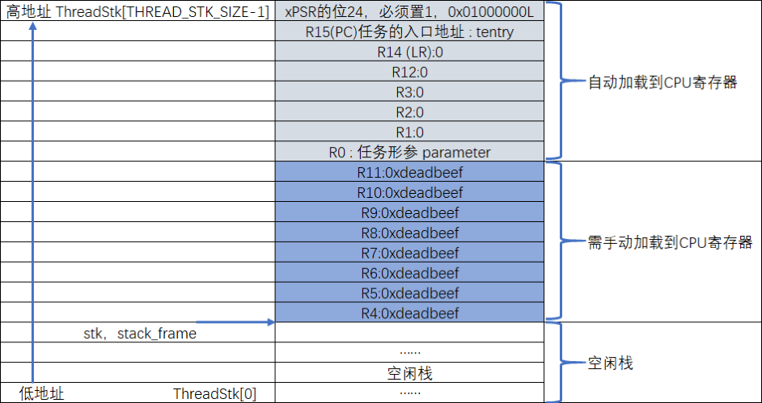

Fig 6-11 content in stack space after initialization

The remaining eight parameters that need to be manually loaded into the CPU registers R4 to R11, are initialized by default to 0xdeadbeaf, as shown in Figure 6-11.

Code listing 6-16(11), return the pointer stk, now it points to the top of the remaining stack space.

Code listing 6-16(12), thread created succeed and return error code- RT_EOK. The error codes of RT-Thread are defined in file rtdef.h. Seeing code listing 6-18.

Code listing 6-18 definition of error codes

1 /*

2 *************************************************************************

3 * 错误码定义

4 *************************************************************************

5 */

6 /* RT-Thread 错误码重定义 */

7 #define RT_EOK 0 /**< There is no error */

8 #define RT_ERROR 1 /**< A generic error happens */

9 #define RT_ETIMEOUT 2 /**< Timed out */

10 #define RT_EFULL 3 /**< The resource is full */

11 #define RT_EEMPTY 4 /**< The resource is empty */

12 #define RT_ENOMEM 5 /**< No memory */

13 #define RT_ENOSYS 6 /**< No system */

14 #define RT_EBUSY 7 /**< Busy */

15 #define RT_EIO 8 /**< IO error */

16 #define RT_EINTR 9 /**< Interrupted system call */

17 #define RT_EINVAL 10 /**< Invalid argument */

In this chapter two threads about flag will be created in the main function, see code listing 6-19.

code listing 6-19 creation of two threads

1 int main**(**void**)**

2 **{**

3 /* initialize hardware */

4 /* software simulation is used now, so,no code here */

5

6

7 /* initialize thread 1 */

8 rt_thread_init**(&**rt_flag1_thread**,** /* thread control block */

9 flag1_thread_entry**,** /* entry function */

10 RT_NULL**,** /* parameter */

11 **&**rt_flag1_thread_stack**[**0**],** /* start address of thread stack */

12 **sizeof(**rt_flag1_thread_stack**));** /* size of thread stack,measured in byte*/

13

14 /* initialize thread 2 */

15 rt_thread_init**(** **&**rt_flag2_thread**,**

16 flag2_thread_entry**,**

17 RT_NULL**,**

18 **&**rt_flag2_thread_stack**[**0**],**

19 **sizeof(**rt_flag2_thread_stack**)** **);**

6.4 Thread Ready Table

6.4.1 Define thread ready table

Thread should be added into ready table after creating, which means the thread is ready and can be scheduled any time. Thread ready table is defined in the file scheduler.c(This is the first time we use scheduler.c, so,create it in directory rtthread\3.0.3\src and add it to project in file group rtt/source) as code listing 6-20.

code listing 6-20 definition of thread ready table

1 /* the thread ready table */

2 rt_list_t rt_thread_priority_table**[**RT_THREAD_PRIORITY_MAX**];** **(**1**)**

code listing 6-19(1), obviously the thread ready table is an array with type rt_list_t and the size of array is RT_THREAD_PRIORITY_MAX, a macro defined in file rtconfig.h, its default value is 32. The subscript represents the thread priority. Threads with same priority will be paced in the same list. Fig 6-12 illustrates an empty thread ready table.

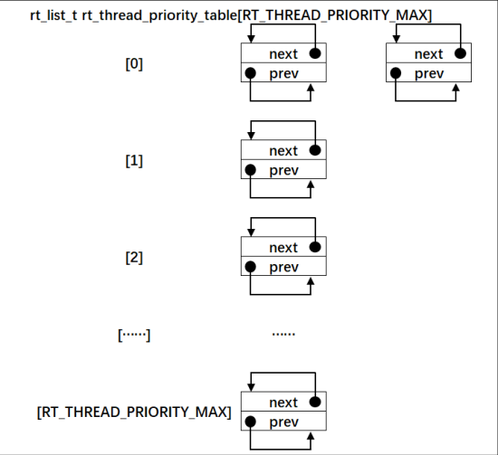

Fig 6-20 an empty thread ready table

6.4.2 insert thread into thread ready table

The member tlist in thread control block can be used to insert a thread into the thread ready table. After creating threads, threads will be inserted into the thread ready list as bold part in code listing 6-21.

Code listing 6-21

1 /* thread init */

2 rt_thread_init**(** **&**rt_flag1_thread**,**

3 flag1_thread_entry**,**

4 RT_NULL**,**

5 **&**rt_flag1_thread_stack**[**0**],**

6 **sizeof(**rt_flag1_thread_stack**)** **);**

7 /* insert thread into thread ready list */

**8 rt_list_insert_before(&(rt_thread_priority_table[0]),&(rt_flag1_thread.tlist));**

9

10 /* thread init */

11 rt_thread_init**(** **&**rt_flag2_thread**,**

12 flag2_thread_entry**,**

13 RT_NULL**,**

14 **&**rt_flag2_thread_stack**[**0**],**

15 **sizeof(**rt_flag2_thread_stack**)** **);**

16 /* insert thread into thread ready list */

17 **rt_list_insert_before( &(rt_thread_priority_table[1]),&(rt_flag2_thread.tlist) );**

The subscript of thread ready table represents of thread priority. The thread doesn’t support priority now, so, the two thread can be insert into anywhere in the table. Thread priority will be introduced in the following chapter. Actually, thread of flag1 was insert into the list with subscript 0 and thread of flag1 was insert into the list with subscript 1. See Fig 6-13.

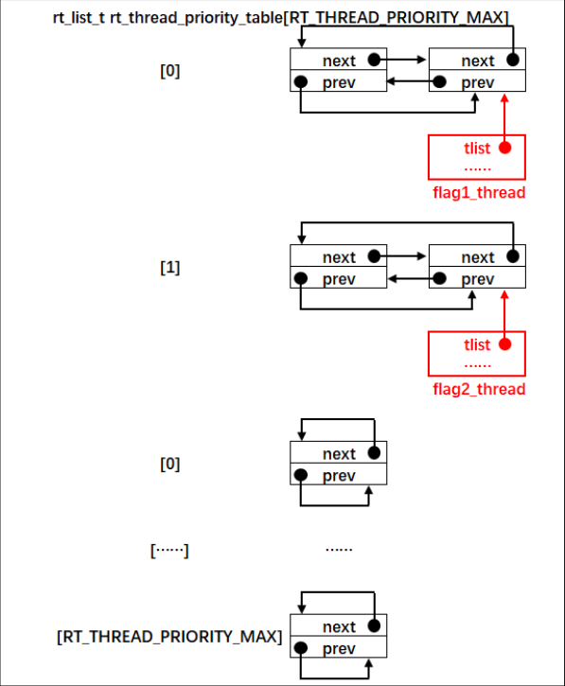

Fig6-13 thread in the thread ready table

6.5 Scheduler

As the core of RTOS, the main duty of scheduler is to find the highest thread in thread ready table and the executes it. The code of scheduler is made up of some global variables and functions that can implement thread switch. All the codes of scheduler are in file scheduler.h.

6.5.1 initialize the scheduler

Before using the scheduler, it must be initialized as the code listing 6-22.

Code listing 6-22 initialization of scheduler

**1 /* initialize the scheduler */**

**2 void rt_system_scheduler_init(void)**

**3 {**

**4 register rt_base_t offset; (1)**

**5**

**6**

**7 /* initialize the thread ready table */**

**8 for (offset = 0; offset** < RT_THREAD_PRIORITY_MAX; offset ++) (2)

9 {

10 rt_list_init(&rt_thread_priority_table[offset]);

11 }

12

13 /* initialize current thread control block pointer */

14 rt_current_thread = RT_NULL; (3)

15 }

Coding list6-22(1):defining a local variable with key words register which can accelerate read/write speed.

Coding list6-22(2): after initializing, the whole thread ready table is empty as fig6-14.

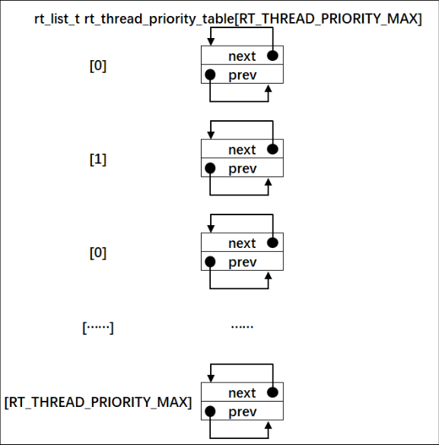

Fig 6-14 an empty thread ready table

Coding list6-22(2): rt_current_thread is a global pointer variable pointing the running thread, but there is no thread is running now, so, set it to NULL.

Normally, the scheduler is initialized after hardware initialization but before thread creating as the bold letters in coding list 6-23.

**Code list 6-23**

**1 int main(void)**

**2 {**

**3 /* hardware initalization */**

**4**

**5**

**6 /* sheduler initalization */**

**7 rt_system_scheduler_init();**

**8**

**9**

**10 /* thread initalization */**

**11 rt_thread_init(** &rt_flag1_thread,

**12 flag1_thread_entry,**

**13 RT_NULL,**

**14** &rt_flag1_thread_stack[**0],**

**15 sizeof(rt_flag1_thread_stack) );**

**16 /* insert thread to thread ready table */**

**17 rt_list_insert_before(** &(**rt_thread_priority_table[0]),**&(**rt_flag1_thread.tlist) );**

**18**

**19**

**20 rt_thread_init(** &rt_flag2_thread,

**21 flag2_thread_entry,**

**22 RT_NULL,**

**23** &rt_flag2_thread_stack[**0],**

**24 sizeof(rt_flag2_thread_stack) );**

**25**

**26 rt_list_insert_before(** &(**rt_thread_priority_table[1]),**&(**rt_flag2_thread.tlist) );**

**27 }**

6.5.2 run the scheduler